**Course: Algorithm  
Prof. Prem Nair  
Student: Binh Van Tran  
ID: 986648  
Homework: Lab 1**

1. **Question 1 – Comparing Algorithm**

In this question, I implement 4 different algorithms

* Algorithm 1: Create a new array consisting of even numbers only. Then use nested loops to solve the problem using the newly created array of even numbers only
* Algorithm 2: Use a nested loop to solve the problem without creating an extra array
* Algorithm 3: Use one loop. Find max and min of even integers. Compute max – min
* Algorithm 4: Use Streams to find the max and min. Compute max – min.

Below is the time running report for the above 4 algorithms with different size of integer arrays: *10000, 20000, 30000, 40000, 50000, 60000, 70000, 80000, 90000 and 100k.* Note that values in array is randomly generated. Duration is in millisecond

|  |  |  |  |  |
| --- | --- | --- | --- | --- |
| **Size of array** | **Alg 1** | **Alg 2** | **Alg 3** | **Alg 4** |
| 10,000 | 91 | 157 | 0 | 59 |
| 20,000 | 226 | 594 | 1 | 1 |
| 30,000 | 436 | 1201 | 1 | 1 |
| 40,000 | 746 | 2115 | 0 | 0 |
| 50,000 | 1070 | 3281 | 1 | 1 |
| 60,000 | 1594 | 4751 | 0 | 1 |
| 70,000 | 2175 | 6425 | 0 | 1 |
| 80,000 | 2493 | 8363 | 0 | 1 |
| 90,000 | 3151 | 10601 | 1 | 0 |
| 100,000 | 3861 | 13049 | 1 | 1 |

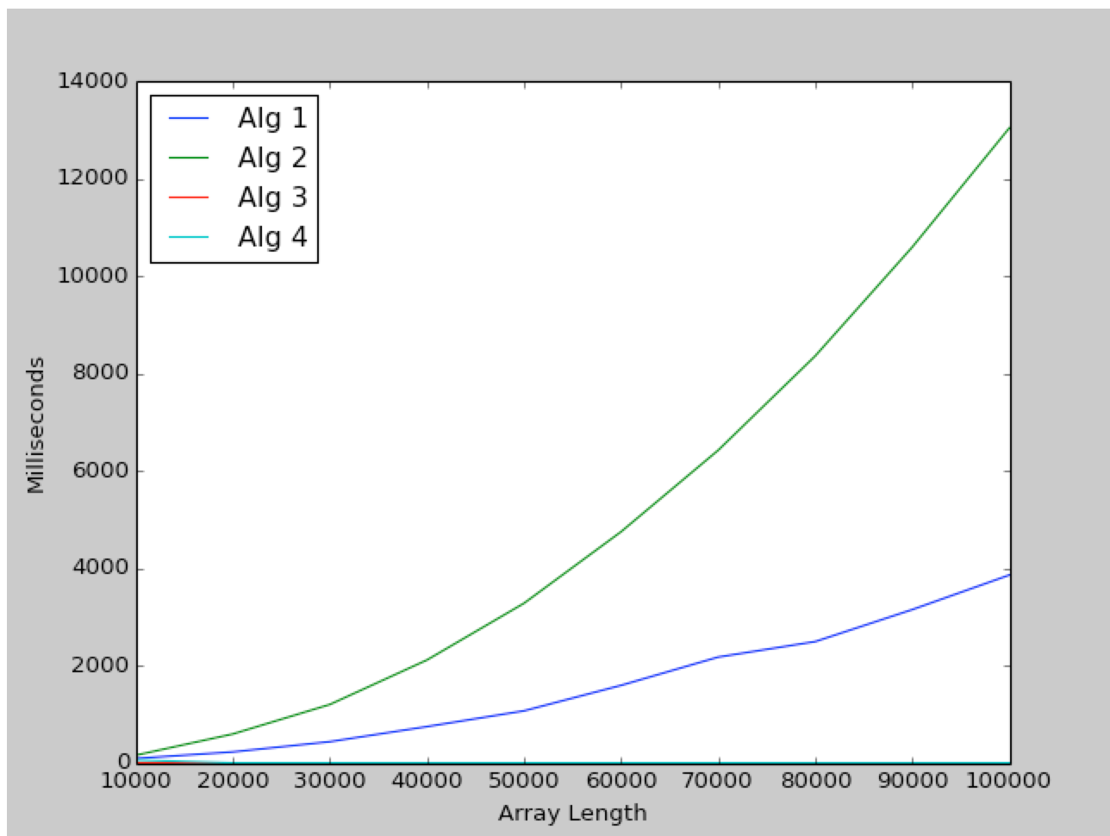

*Figure 1: Graph of 4 algorithms*

As we can see, the **Alg 3, 4** is very efficient although the size of the array is increasing, the time for computation is not increasing. While the two first Algorithm is not as good as the two last which is using one loop and stream. Algorithm 2 with loop inside a loop has worst performance.

In term of space (the memory), algorithm 1 use one additional array for even number that means it costs more memory as compared to the last 3 algorithms.

For more detail, please look at *Question1.java*

1. **Question 2 – Proof by induction**

Let F(n) denote the nth Fibonacci number. Prove $F(n) > {\left(\frac{4}{3}\right)}^{n}$ for n > 4

**Base cases**:

$$n=5=>F\left(5\right)>{\left(\frac{4}{3}\right)}^{5}$$

$$n=6=>F\left(6\right)> {\left(\frac{4}{3}\right)}^{6}$$

Clearly, the result holds.

**Hypothesis:** Assume the result is true for all values of n in the interval $[5, 6, …, m]$ $F\left(m\right)>{\left(\frac{4}{3}\right)}^{m}$. That is, m is the largest value for which the result is true

**Induction step:** We need to prove the following is true

$$F\left(m+1\right)>{\left(\frac{4}{3}\right)}^{m+1}\left(1\right) \\ F\left(m+1\right)= F\left(m\right)+F\left(m-1\right) \\ F\left(m+1\right)={\left(\frac{4}{3}\right)}^{m}+ {\left(\frac{4}{3}\right)}^{m-1} \\ Due to \left(1\right): {\left(\frac{4}{3}\right)}^{m}+ {\left(\frac{4}{3}\right)}^{m-1}>{\left(\frac{4}{3}\right)}^{m+1} \\ ⟺ {\left(\frac{4}{3}\right)}^{m}+ \frac{3}{4}{\left(\frac{4}{3}\right)}^{m}>{\frac{4}{3}\left(\frac{4}{3}\right)}^{m} \\ ⟺ {\left(\frac{4}{3}\right)}^{m}\left(1+ \frac{3}{4}\right)>{\frac{4}{3}\left(\frac{4}{3}\right)}^{m} \\ ⟺ 1+ \frac{3}{4}>\frac{4}{3} \\ ⟺ \frac{7}{4}>\frac{4}{3}⟺ \frac{21}{12}>\frac{16}{12} \left(2\right)$$

**(2)** is clearly true.So the problem is proved